Game Symbol Cheat Sheet (Unicode escapes)

1️⃣ Lottery / Chance
Symbol | Escape | Use
🎰 | \u{1F3B0} | Slot machine / lottery win
🎲 | \u{1F3B2} | Dice / random chance
🃏 | \u{1F0CF} | Joker / wildcard
🎯 | \u{1F3AF} | Target hit / correct guess

2️⃣ Stats / Score
Symbol | Escape | Use
📊 | \u{1F4CA} | Score chart / results
📈 | \u{1F4C8} | Level up / growth
📉 | \u{1F4C9} | Loss / penalty
🧮 | \u{1F9EE} | Counting / calculation

3️⃣ Wins / Achievements
Symbol | Escape | Use
🏆 | \u{1F3C6} | Trophy / winner
🥇 | \u{1F947} | First place
🎖️ | \u{1F396} | Medal / achievement
⭐ | \u{2B50} | Star / bonus
🎉 | \u{1F389} | Celebration / party

4️⃣ Power-ups / Energy / Effects
Symbol | Escape | Use
⚡ | \u{26A1} | Energy / speed boost
⏱️ | \u{23F1} | Timer / countdown
💥 | \u{1F4A5} | Explosion / penalty
🪄 | \u{1FA84} | Magic / power-up
🔥 | \u{1F525} | Hot streak / fire effect
💎 | \u{1F48E} | Bonus / rare reward

5️⃣ Feedback / Reactions
Symbol | Escape | Use
👍 | \u{1F44D} | Correct / success
👎 | \u{1F44E} | Wrong / retry
😃 | \u{1F603} | Happy / win
😢 | \u{1F622} | Sad / lose
🤯 | \u{1F92F} | Mind-blown / special event
😎 | \u{1F60E} | Cool / perfect move

6️⃣ Navigation / UI
Symbol | Escape | Use
⬆️ | \u{2B06} | Up / next
⬇️ | \u{2B07} | Down / previous
⬅️ | \u{2B05} | Left / back
➡️ | \u{27A1} | Right / continue
🔄 | \u{1F504} | Reset / replay
🖱️ | \u{1F5B1} | Click / action hint

7️⃣ Misc / Fun / Visuals
Symbol | Escape | Use
🎵 | \u{1F3B5} | Music / sound
💡 | \u{1F4A1} | Hint / idea
🧩 | \u{1F9E9} | Puzzle piece
🎁 | \u{1F381} | Reward / prize
🏹 | \u{1F3F9} | Aim / precision
🔔 | \u{1F514} | Notification / alert
💣 | \u{1F4A3} | Explosion / trap

Wrong / Incorrect Feedback Symbols
Symbol | Escape | Use
❌ | \u{274C} | Clear “wrong” / error
⚠️ | \u{26A0} | Warning / caution
👎 | \u{1F44E} | Negative / try again
💣 | \u{1F4A3} | Boom / totally off
🤦 | \u{1F926} | “Oops” / facepalm — playful

2️⃣ Friendly / Encouraging Symbols
Symbol | Escape | Use
😊 | \u{1F60A} | Smile / “nice try”
🐾 | \u{1F43E} | Playful / cute encouragement
🍀 | \u{1F340} | Luck / “better next time”
💡 | \u{1F4A1} | Hint / learning opportunity

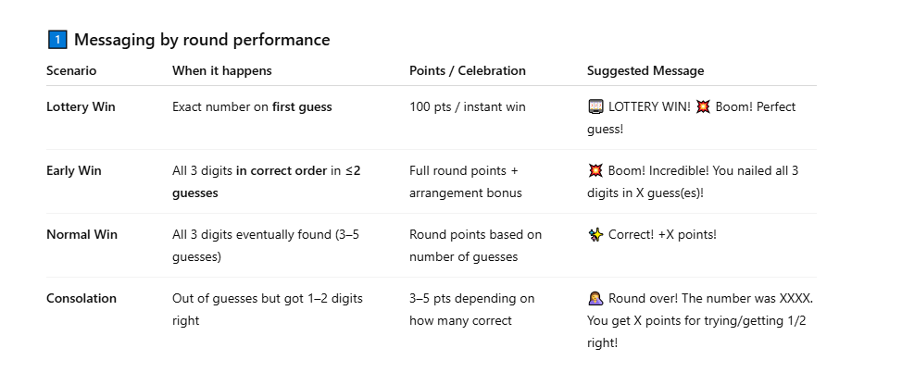
setMessage(`EMOJI Your dynamic text here!`);

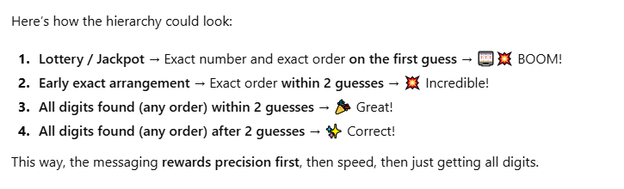

SCORING & MESSAGING RULES

1) LOTTERY WIN
When it happens:
- Exact number guessed on the FIRST guess only

Points / Outcome:
- +100 points
- Instant round win

Message:
🎰 LOTTERY WIN!
💥 Boom! Perfect guess! +100 points!

2) EARLY WIN
When it happens:
- All 3 digits guessed in the correct order
- Solved in 2 guesses or fewer
- NOT a lottery Win (i.e., not first guess)

Points / Outcome:
- Normal round points
- Arrangement bonus applied

Message:
💥 Boom! Incredible!
You nailed all 3 digits in X guess(es)!

3) NORMAL WIN
When it happens:
- All 3 digits guessed in the correct order
- Solved in 3–5 guesses

Points / Outcome:
- Round points based on guess count

Message:
✨ Correct!
+X points!

4) CONSOLATION
When it happens:
- Player runs out of guesses
- At least 1 digit was correct during the round

Points / Outcome:
- 3–5 points depending on best guess

Message:
🤦 Round over!
The number was XXX.
You get X points for trying / getting 1–2 right.

🎯 Number Game Tailwind Cheat Sheet
Tailwind Class | Where Used | What It Does | Example Change
w-14 | Buttons | Width = 56px | w-12 → smaller buttons
h-14 | Buttons | Height = 56px | h-16 → taller buttons
text-xl | Buttons | Font size ~18px | text-2xl → bigger text
bg-white/20 | Buttons | White background, 20% opacity | bg-white/30 → slightly brighter
hover:bg-white/30 | Buttons | Hover effect | hover:bg-gray-300 → change hover color
rounded-lg | Buttons | Corner radius ~8px | rounded-md → smaller rounded corners
cursor-not-allowed | Buttons when disabled | Shows disabled cursor | Remove to keep pointer cursor
text-white | Buttons | Font color white | text-black → black font
bg-gray-500/40 | Disabled buttons | Gray background with opacity | bg-gray-300/40 → lighter gray
grid | Number pad container | Sets display: grid | N/A
grid-cols-3 | Number pad container | 3 columns | grid-cols-4 → 4 columns
gap-3 | Number pad container | Gap between grid items | gap-2 → smaller spacing
w-72 | Number pad container | Width = 288px | w-64 → narrower pad
mx-auto | Number pad container | Centers horizontally | N/A
mb-6 | Number pad container | Margin-bottom ~24px | mb-4 → smaller bottom margin

